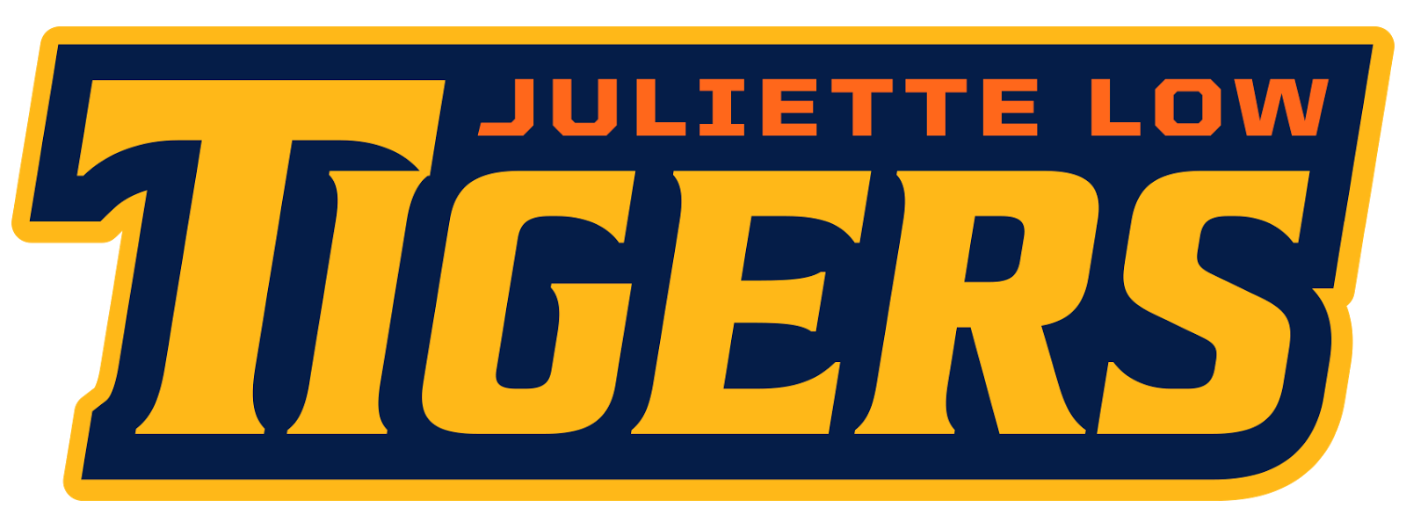

Healthy Snack / Birthday Treat
Why healthy snacks and non-edible birthday treats?
- To promote healthy lifestyle choices for students
- This year parents and teachers are asked to provide an alternative to food for birthday and holiday celebrations, student motivators, and rewards. There are some wonderful methods to celebrate birthdays/holidays and reward positive student behaviors and achievements without using edible treats.
- USDA comparison of old to new standards

Healthy Snacks: | Birthday Treats/Holiday Treats:
For those classes that have snack as part of the instructional day, please make sure that a healthy snack is packed for your child. Please keep the snack simple to eat. Specific classroom guidelines should be discussed with your child’s teacher, especially if there are food restrictions of food allergies.  Please send a snack from one of the following options:  - Frozen fruit/juice popsicles  - Sliced fruit  - Low fat muffins  - Cereal party mix  - Granola bars  - Low fat pudding cups  - 100 calorie packs of treats  - Flavored rice cakes  - Pretzels  - Dried fruits  - Low fat yogurt  - Baked chips  - String cheese | Cupcakes with frosting, cakes, cookies, doughnuts, candy, brownies etc. are all part of a high sugar diet that does not follow a healthy eating routine.  Juliette Low School would like to ensure that our students are making healthy choices not just as part of hot lunch but also with birthday and holiday treats.  We ask that you do not send Halloween or Valentine candy during the holidays. We will celebrate during classroom parties with either a selection from the healthy snacks list or a non-edible treat.  Non-edible treat suggestions may include but are not limited to the following:  - Pencils  - Books  - Erasers  - Markers, Crayons, Colored Pencils  - Post It notes

